# Steps to download Fuzzymatcher

Fuzzymatcher module is used for identifying patterns. Please follow the following steps to download fuzzymatcher module successfully on your machine.

1. Download visual studio latest version (<https://visualstudio.microsoft.com/downloads/#build-tools-for-visual-studio-2019> ) if you don’t have it on your machine. I already had visual studio 2017 I reused the same (Both these steps will require a restart).

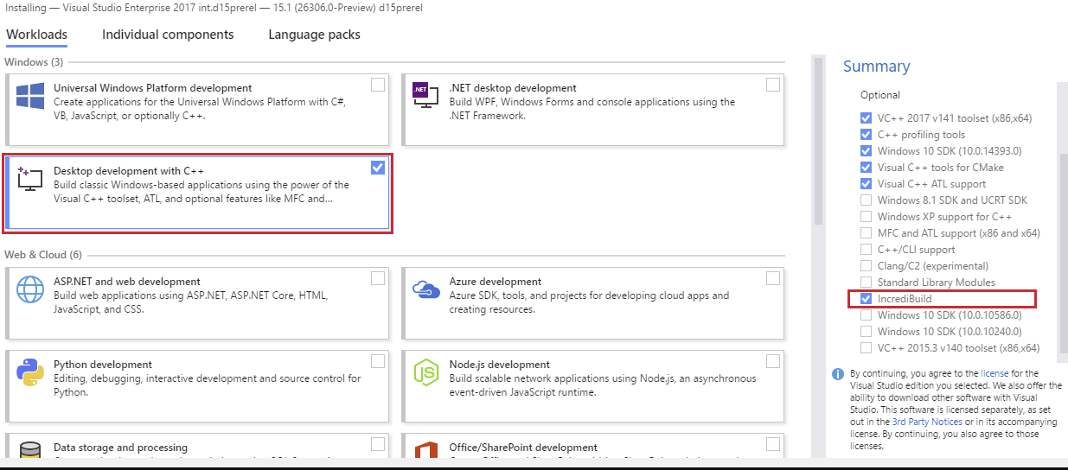

Make sure to select desktop development with C++ and include the incrediBuild. This will ensure while installing the fuzzymatcher you will not get the build issue.

1. The second issue will occur if the NumPy build is should be greater than 1.15.4. else update the NumPy using

pip install NumPy –upgrade

(sometimes you would need to use –user command in case of failure, the command will be updated to pip install NumPy --upgrade --user )

1. During the process I also realized that my pip command was outdated so I even update pip command using

python -m pip install –upgrade pip

1. After following all this steps, I installed fuzzymatcher

pip install fuzzymatcher -- user

Hope this step helps. Since I was not able to get detail explanation anywhere about this download, I decided to put this together for anyone having similar issue while installing fuzzymatcher.